Table Of Content

E-PROJECT
Group Members 2
Certificate of Completion 3
Acknowledgment 4
Synopsis Project 5
Problem Statement 6
Hardware and Software Requirements 7
Architecture and Design of the system 8
Site Map 9
Developer Guide Through code
Home page 10
Décor page code 12
Categories page code 12
Contact us page code 13
About Page Code 14
Compare Page code 15
Main Navigation
Home page 16
Contact us 17
About us 18
Compare product 19
Décor page 20
Categories page 21
Task Sheet 22

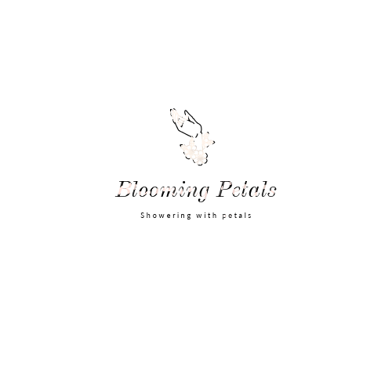

Group Member IDs | Group Member Names
1600501 | Tameen Fatima
1600086 | Sana Siddiqui
1598618 | Sana Sajjad
1599282 | Yumna Asim

Batch code: AI-202408E1

Certificate of Completion

This is to certify that Tameen Fatima, Sana Siddiqui, Sana Sajjad and
Yumna asim have successfully completed their CPISM Semester I E-Project.

Submitted to: Aptech Computer Education
On
January 5th, 2025

Acknowledgement

First of all we would like to thank Almighty Allah for giving us strength and ability to complete this project.
And then, we would like to express my special thanks of gratitude to our teacher Sir Talha Ahmed who guided us on the project Floral Decors which also helped us in doing a lot of new learning and we came to know about so many new things we are really thankful to him.
We are highly thankful to Sir Talha Ahmed for his guidance and constant supervision as well as for providing necessary information regarding the project & also for his support in completing the project.
Lastly, we would also like to thank our parents and friends who helped us a lot in finalizing this project within the limited time frame. We also express our sincere gratitude to E-Project team from Aptech Head Office, for their valuable guidance and support for the completion of this project. We earnestly hope that this project will provide all the necessary information required by the user to fulfill his/her inspiration. However, suggestion and Feedbacks for improvements will be thankfully welcomed & acknowledged.

Synopsis Project

BLOOMING PETALS the store is Branded Company famous for Floral Decors. It provides collection of n number of appliances with different category to match the fast life of the generation. The group of BLOOMING PETALS companies had made huge profit in the year 2024. In order to enhance its business, we’re developing their site.
Problem Statement

“Blooming Petals” is selling various types of flowers and floral decorations. The company advertises by distributing the pamphlets, advertising on television and so on. Due to rapid development in internet field, the company decides to launch a website where people will get all the information about the various products available with them easily.

Requirement Specification:
The Web site is to be created based on the following requirements.

- The Home Page should be created with sections, graphics and with a suitable logo.
- Home Page should contain details of different flowers/floral decors with suitable images.
- The site should display a menu which will contain the options for brief introduction about the various floral themes/decorations available, location of the shop and any other information if required.
- The information about products should be presented in two ways:
        - Information should be available category wise, wherein user can click on a particular category and should be able to view all the products related to the category available with complete information. Eg. Category can be “Birthdays”, “Anniversaries”, marriages” etc. with suitable sub-categories been defined.
        - Information should be categorized according to the type of flowers like if a User wants to see only “Rose decors” or any other particular flower products then he/she can click on a Link/button/menu etc and can see only that products.
- When a user selects any particular flower, a list of products for that brand will be displayed
- A brief summary of individual products should be displayed on the Web Page along with the product but detailed Features should be stored in Individual Word documents which can be downloaded or viewed by the User who wishes to see the same.
- The user should also be able to compare the various products of different as well as similar categories.
- There should be a “Contact Us” page which will have the Address of the Company with location should be displayed using GeoLocation API (eg. GoogleMaps) and the mail address which when clicked will invoke the local mail client from where they can send an email.

Hardware and Software Requirements

Hardware
- A minimum computer system that will help you access all the tools in the courses is a Pentium 166 or better
- 64 Megabytes of RAM or better

Software [Either or Combination as per Course/Sem]
- Notepad/HTML editor/ CoffeeCup
- Angular / Angular JS / React / BootStrap
- Dreamweaver / Figma
- MS IE / Chrome / FireFox / Netscape /MS Edge

Architecture and Design of the System

The application will have a client-server architecture.
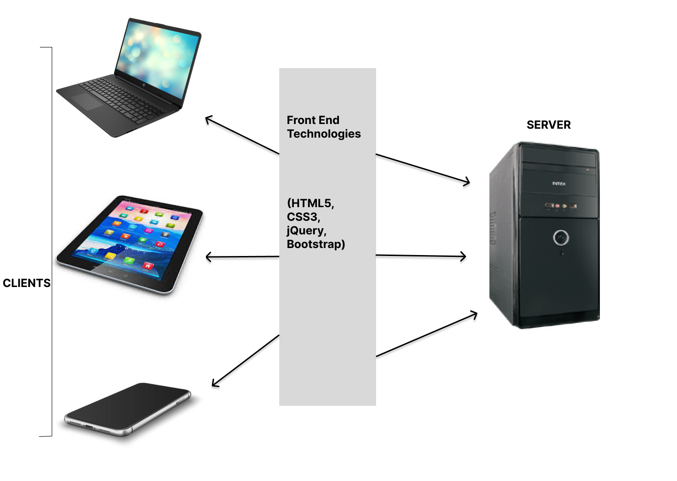

Client-server Architecture of the Project.

Site Map:

BLOOMING PETALS

Categories
Compare-products
Contact-us
About-us
Decors

Compare any two products
Contact no
Email

Name
Contact us
Our Team
Our Mission
Sunflower
Marigold
Lavender
Orchid
Daisy
Daffodil
Dahlia
Lily
Baby’s Breath
Crocus
Aster
Tulips
Dandelions
Rose
Bridal shower
Anniveraries
wedding
Eid wish
Get well soon
Baby Shower
Mother’s Day
Birthday
Convocation
Father’s Day
Valentine’s day
Friendship day

Developer’s Guide through Code:

Home Page:
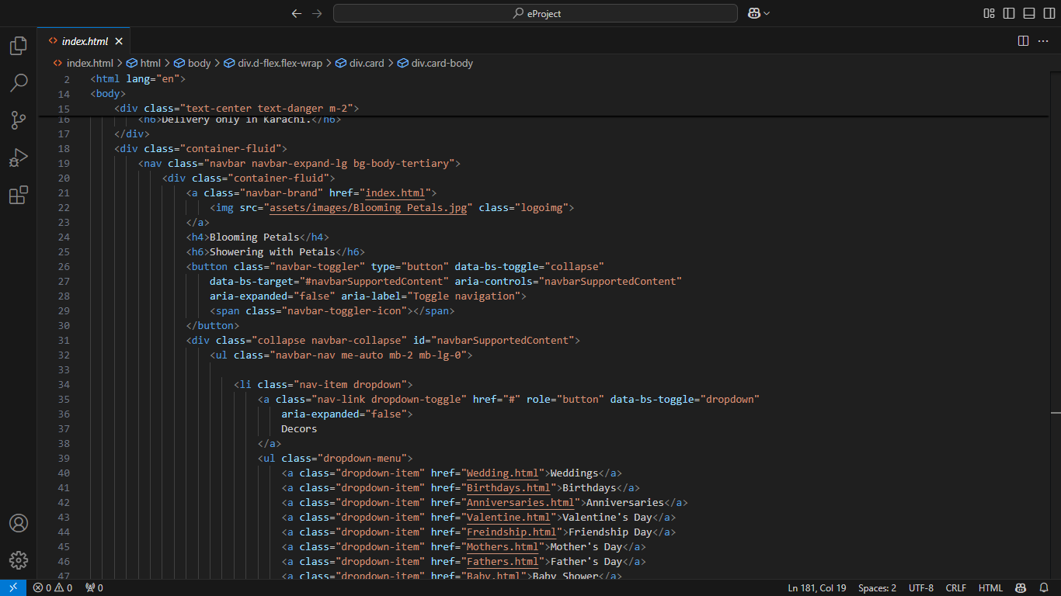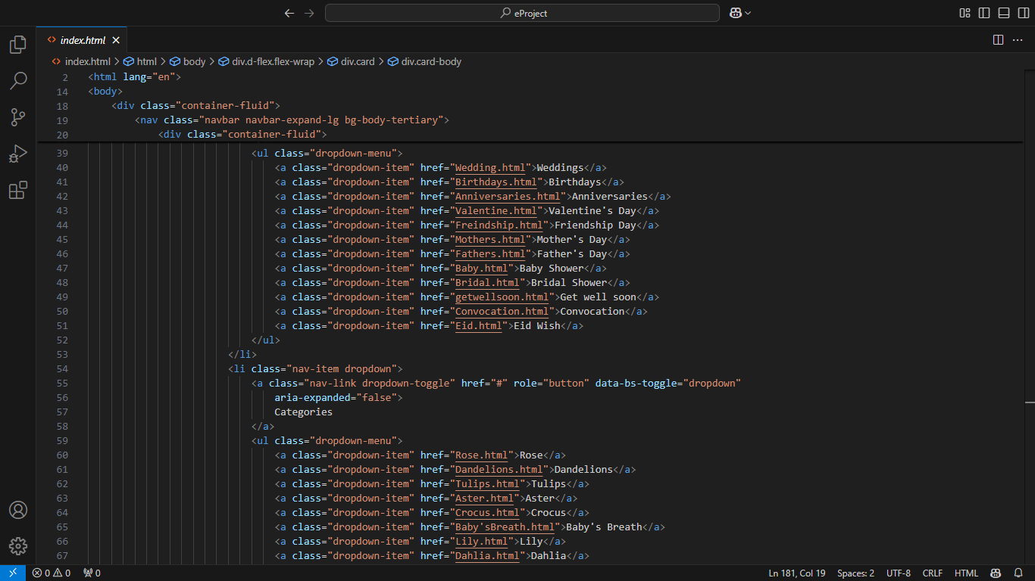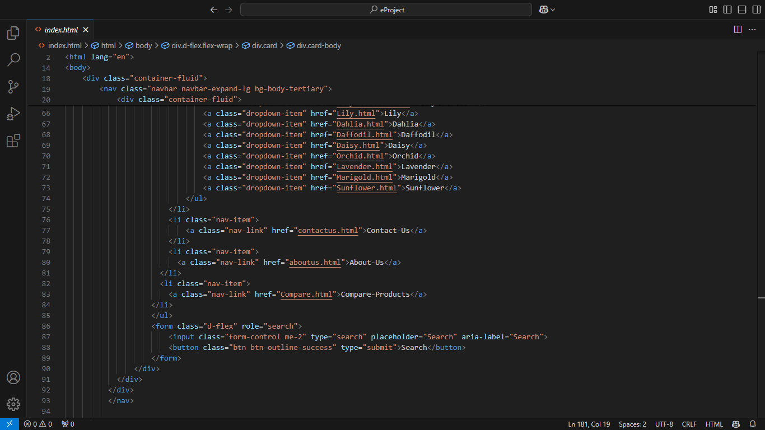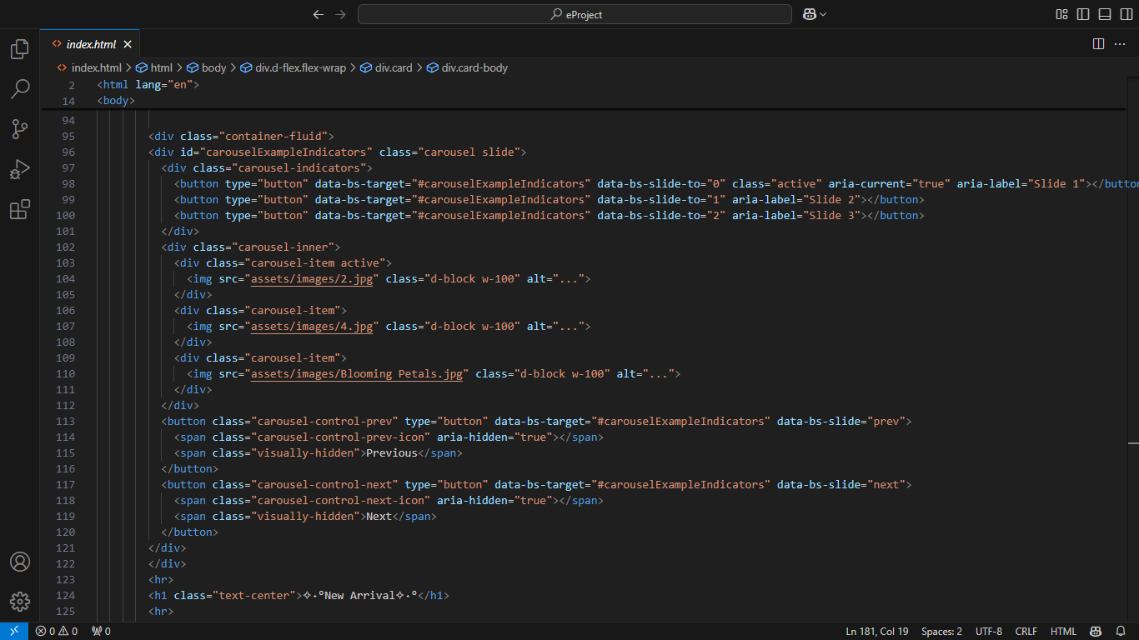

Decor’s Page Code:

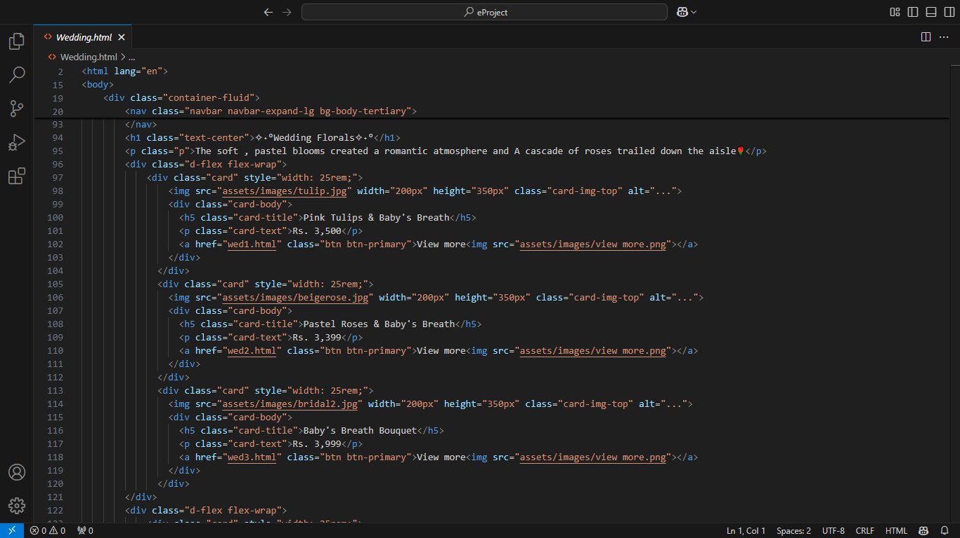

Categories Page Code:

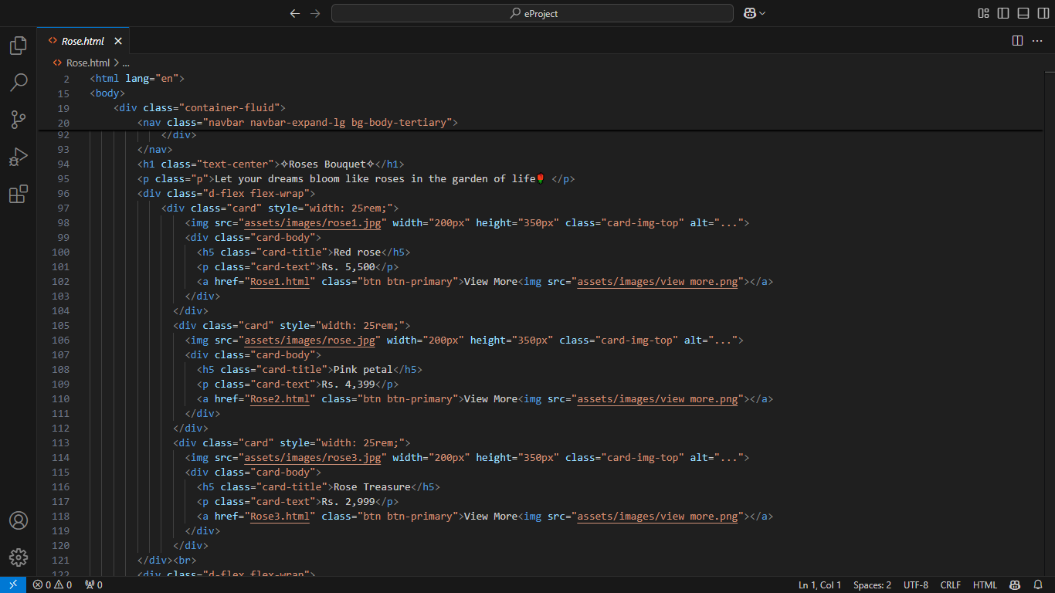
Contact Page Code:

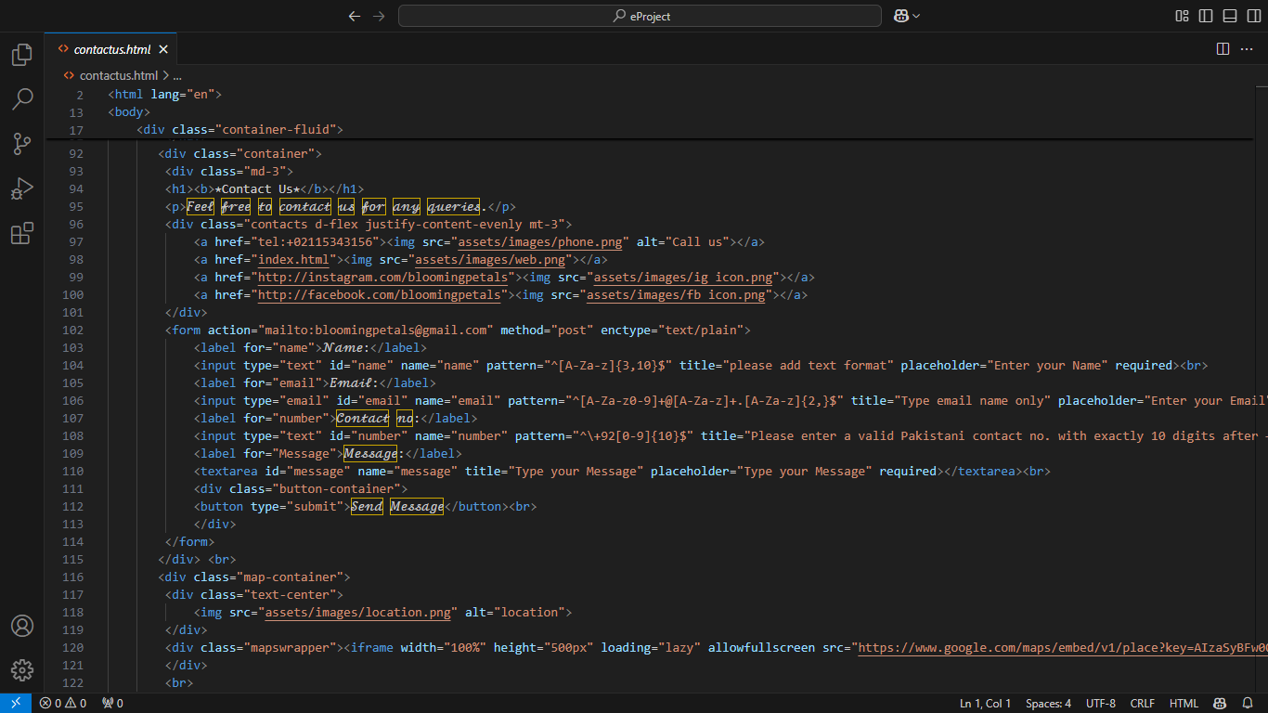
About Page Code: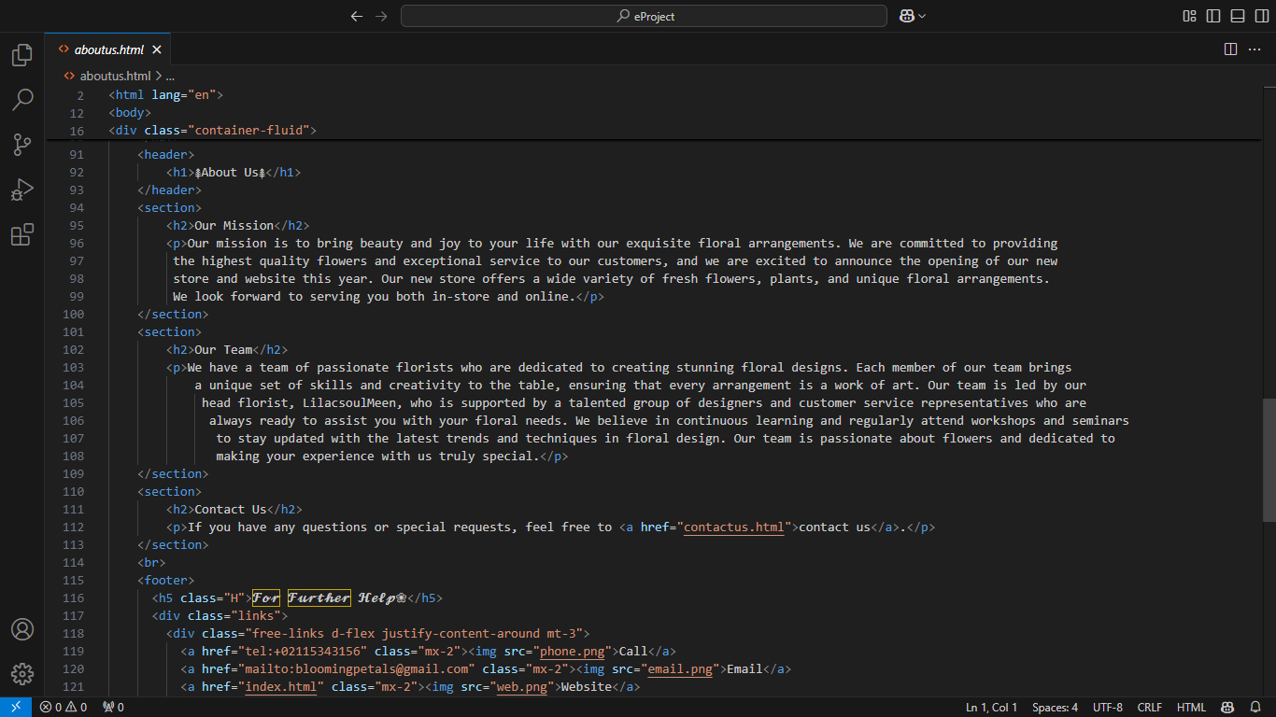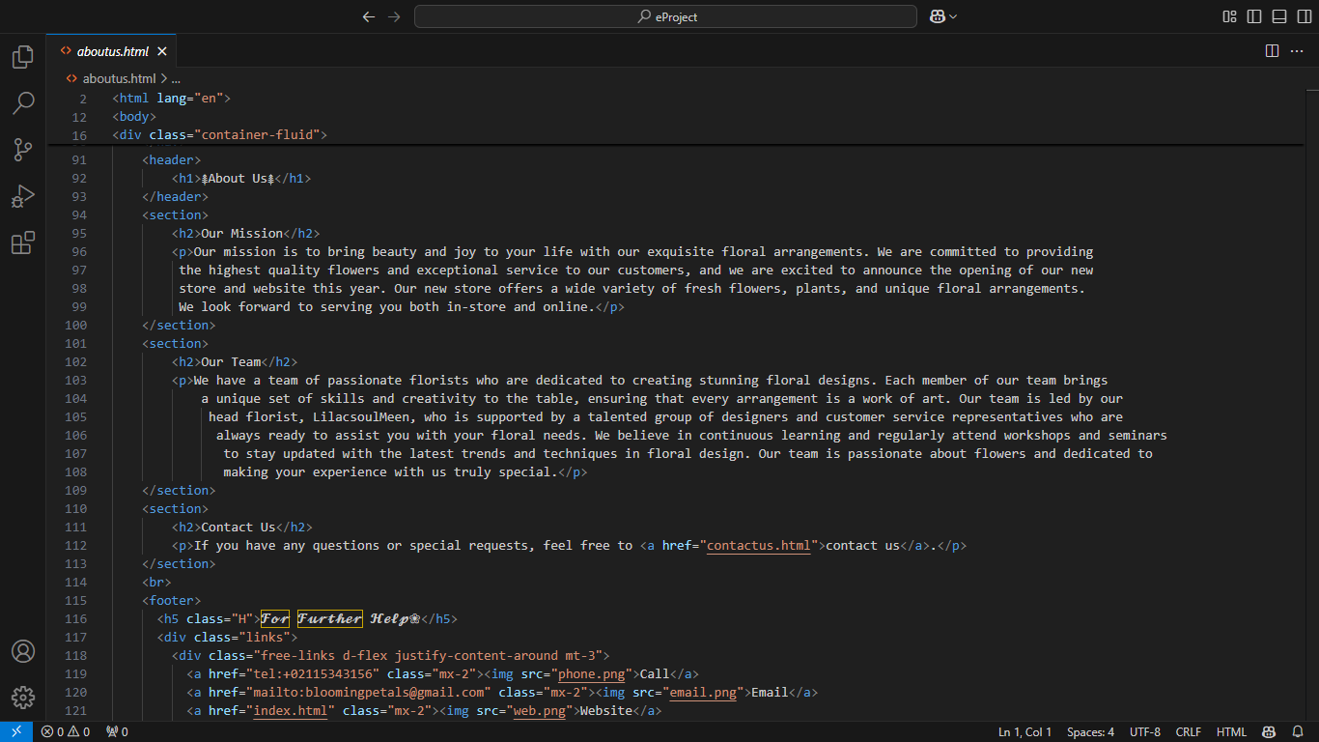

Compare Products Page Code: 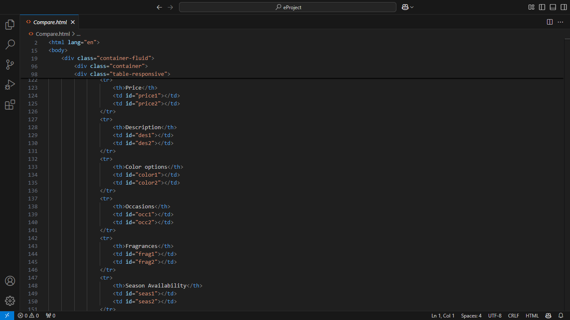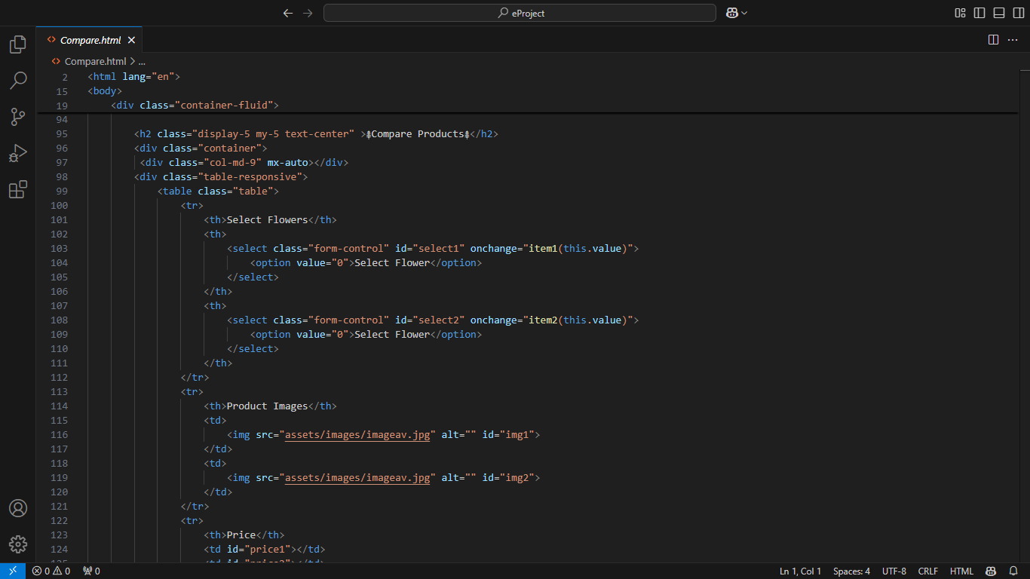
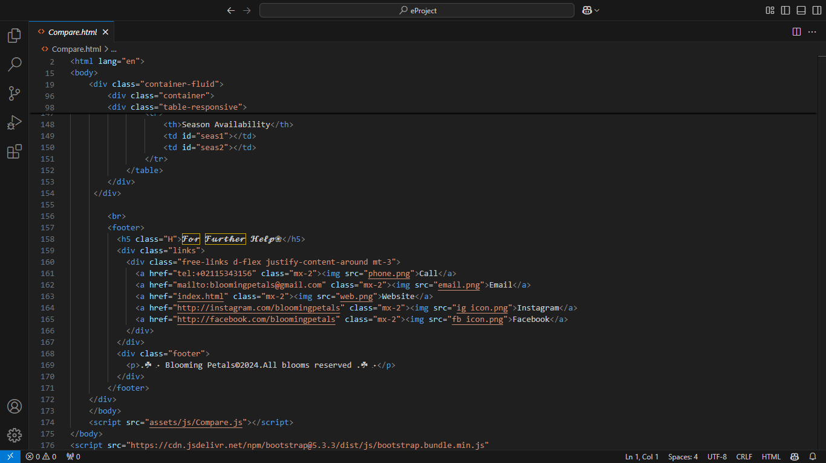

Main Navigation:
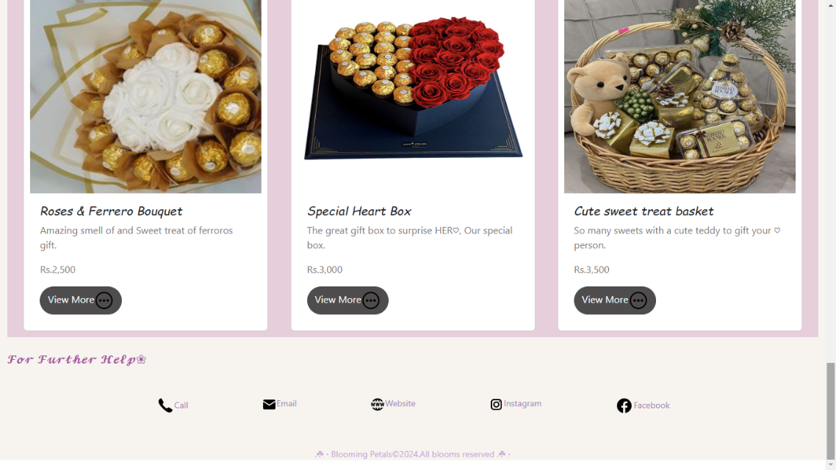
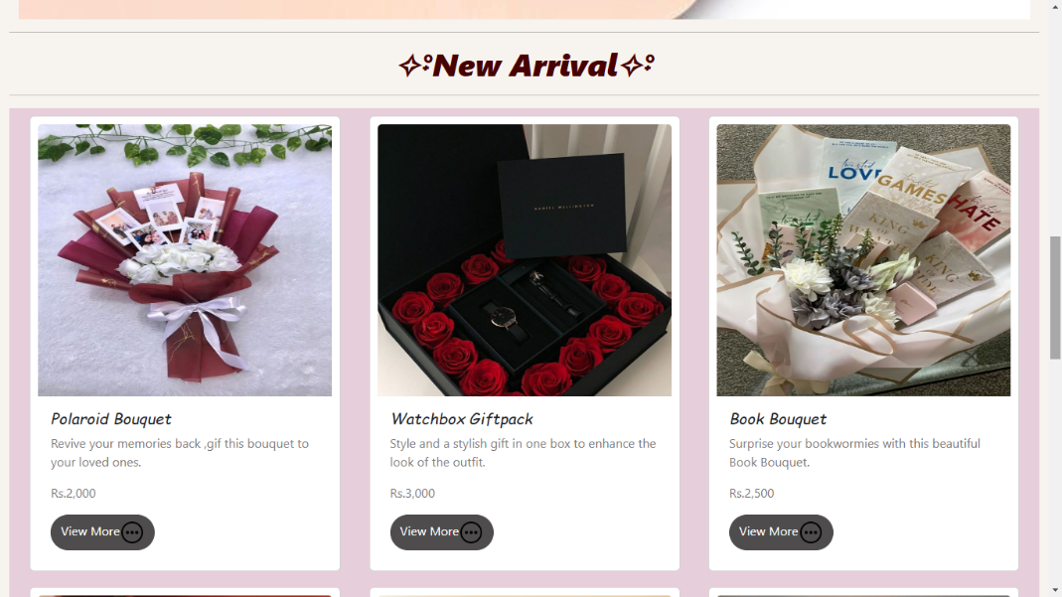
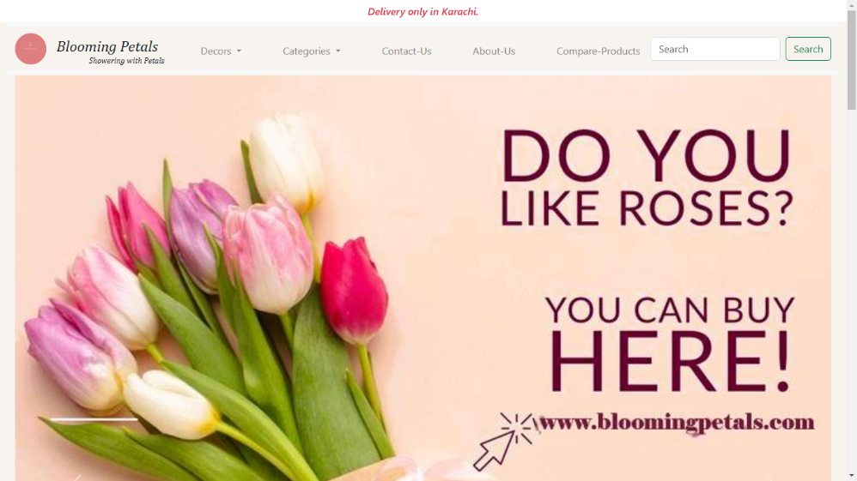
Home Page:

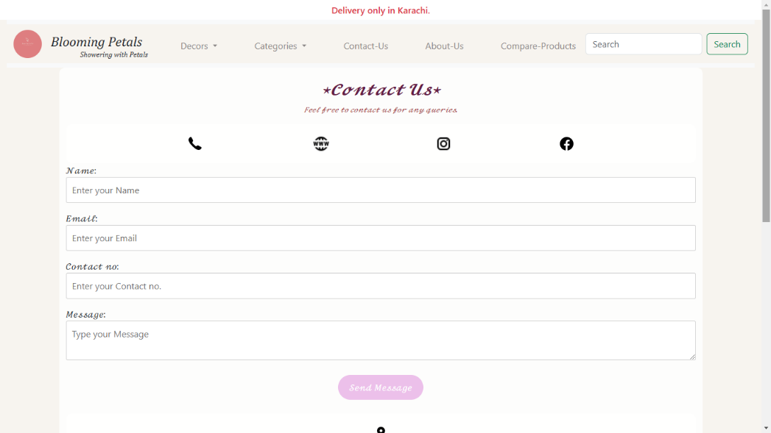
Contact us:

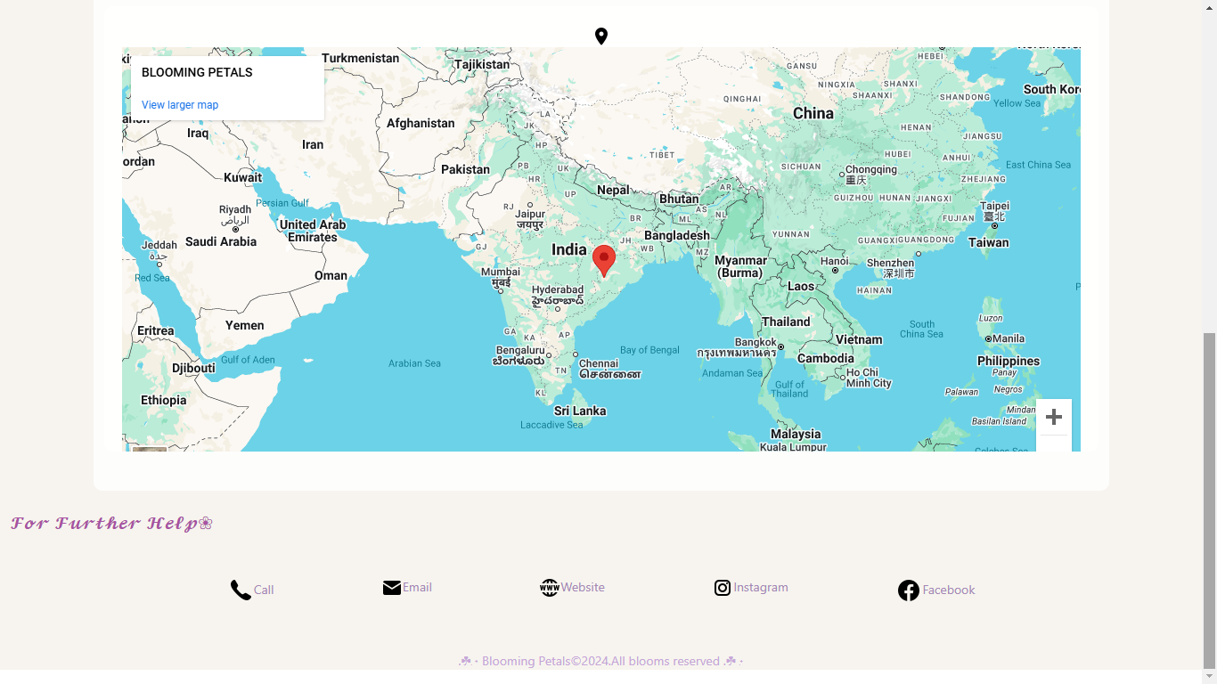

About us:
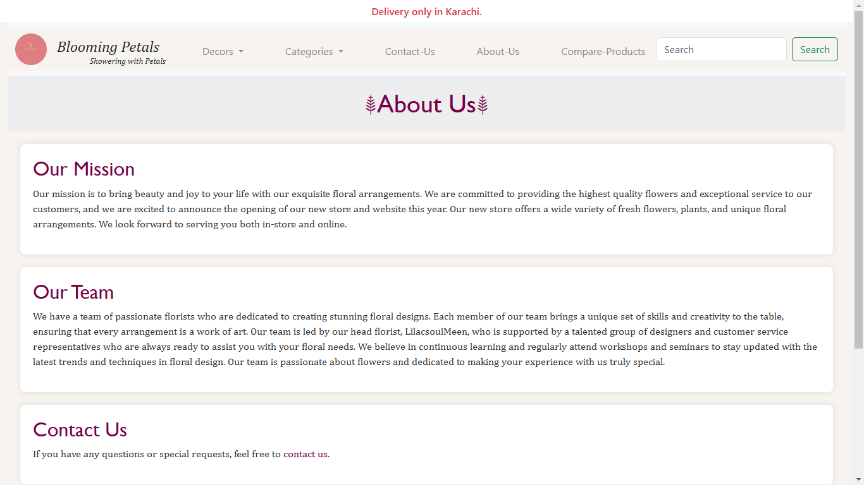

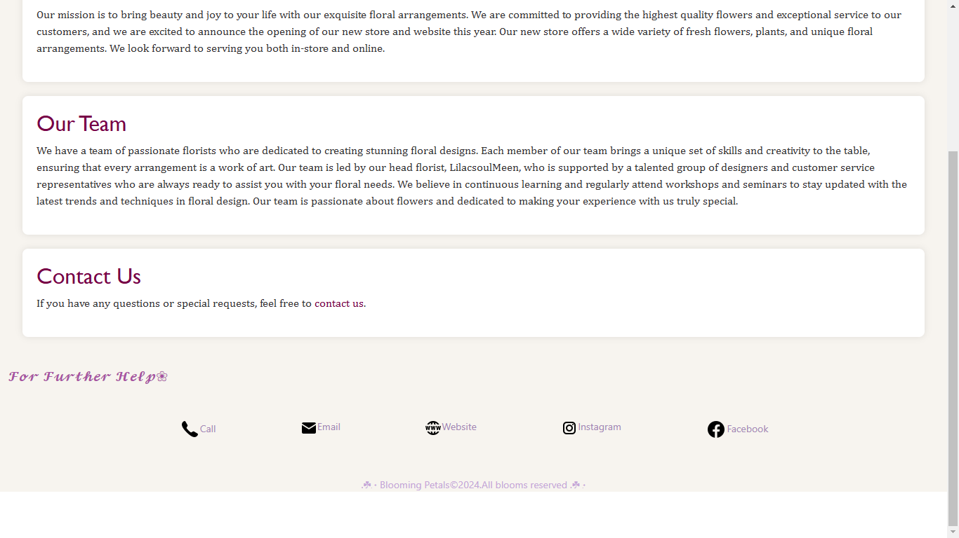

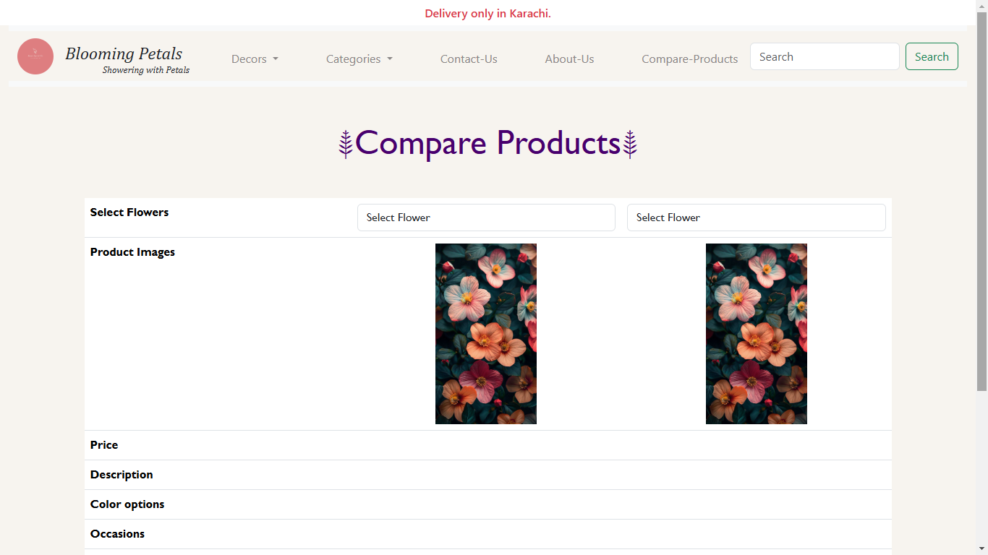
Compare-Products:

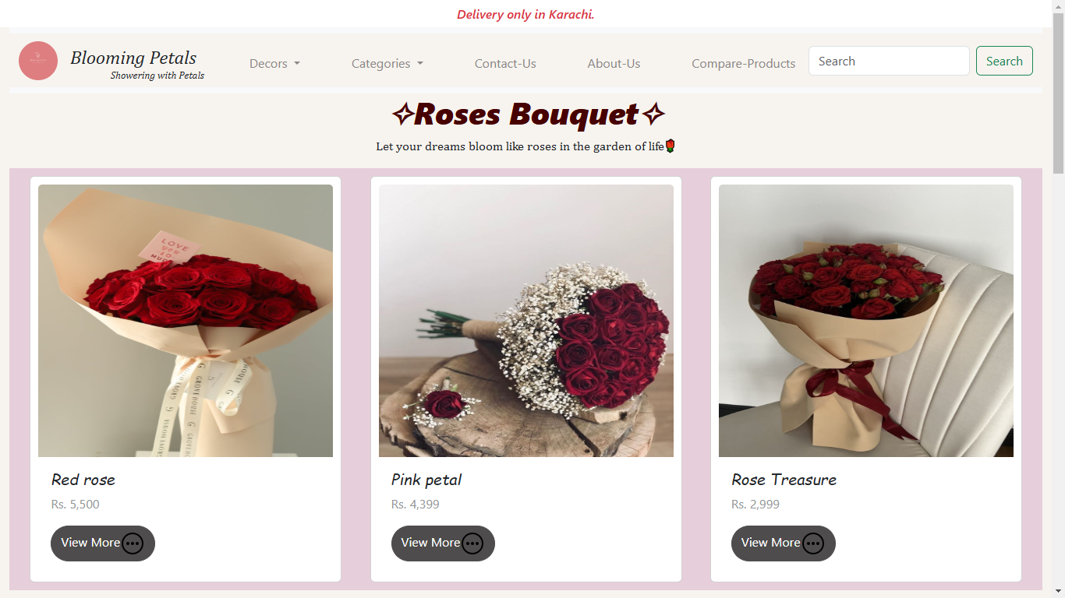
Decors:

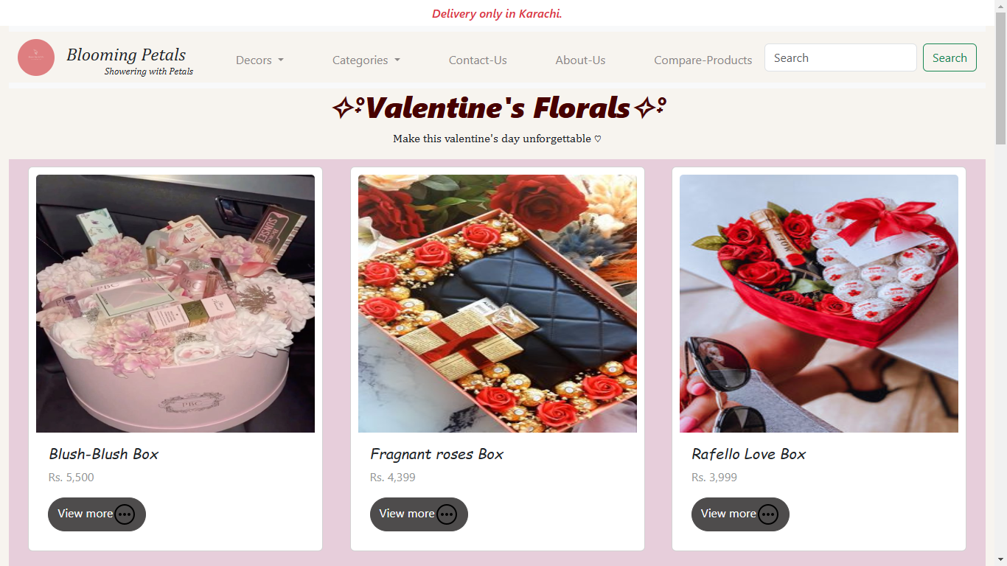
Categories:
Task Sheet:

Project Ref. No. |  | Project Title | Date of Preparation of Activity Plan
S.No. | Task | BLOOMING PTELS | Actual Days | Status
1 | Analysis | BLOOMING PTELS | 2 | OK
2 | Design | BLOOMING PTELS | 3 | OK
3 | Development | BLOOMING PTELS | 18 | OK
4 | Testing | BLOOMING PTELS | 2 | OK
5 | Documentation | BLOOMING PTELS | 1 | OK

